May 2026 WOLF CREEK EVENTS 

Sun | Mon | Tue | Wed | Thu | Fri | Sat
 |  |  |  |  | 1 | 2
3 | 4 | 5  Cinco de Mayo  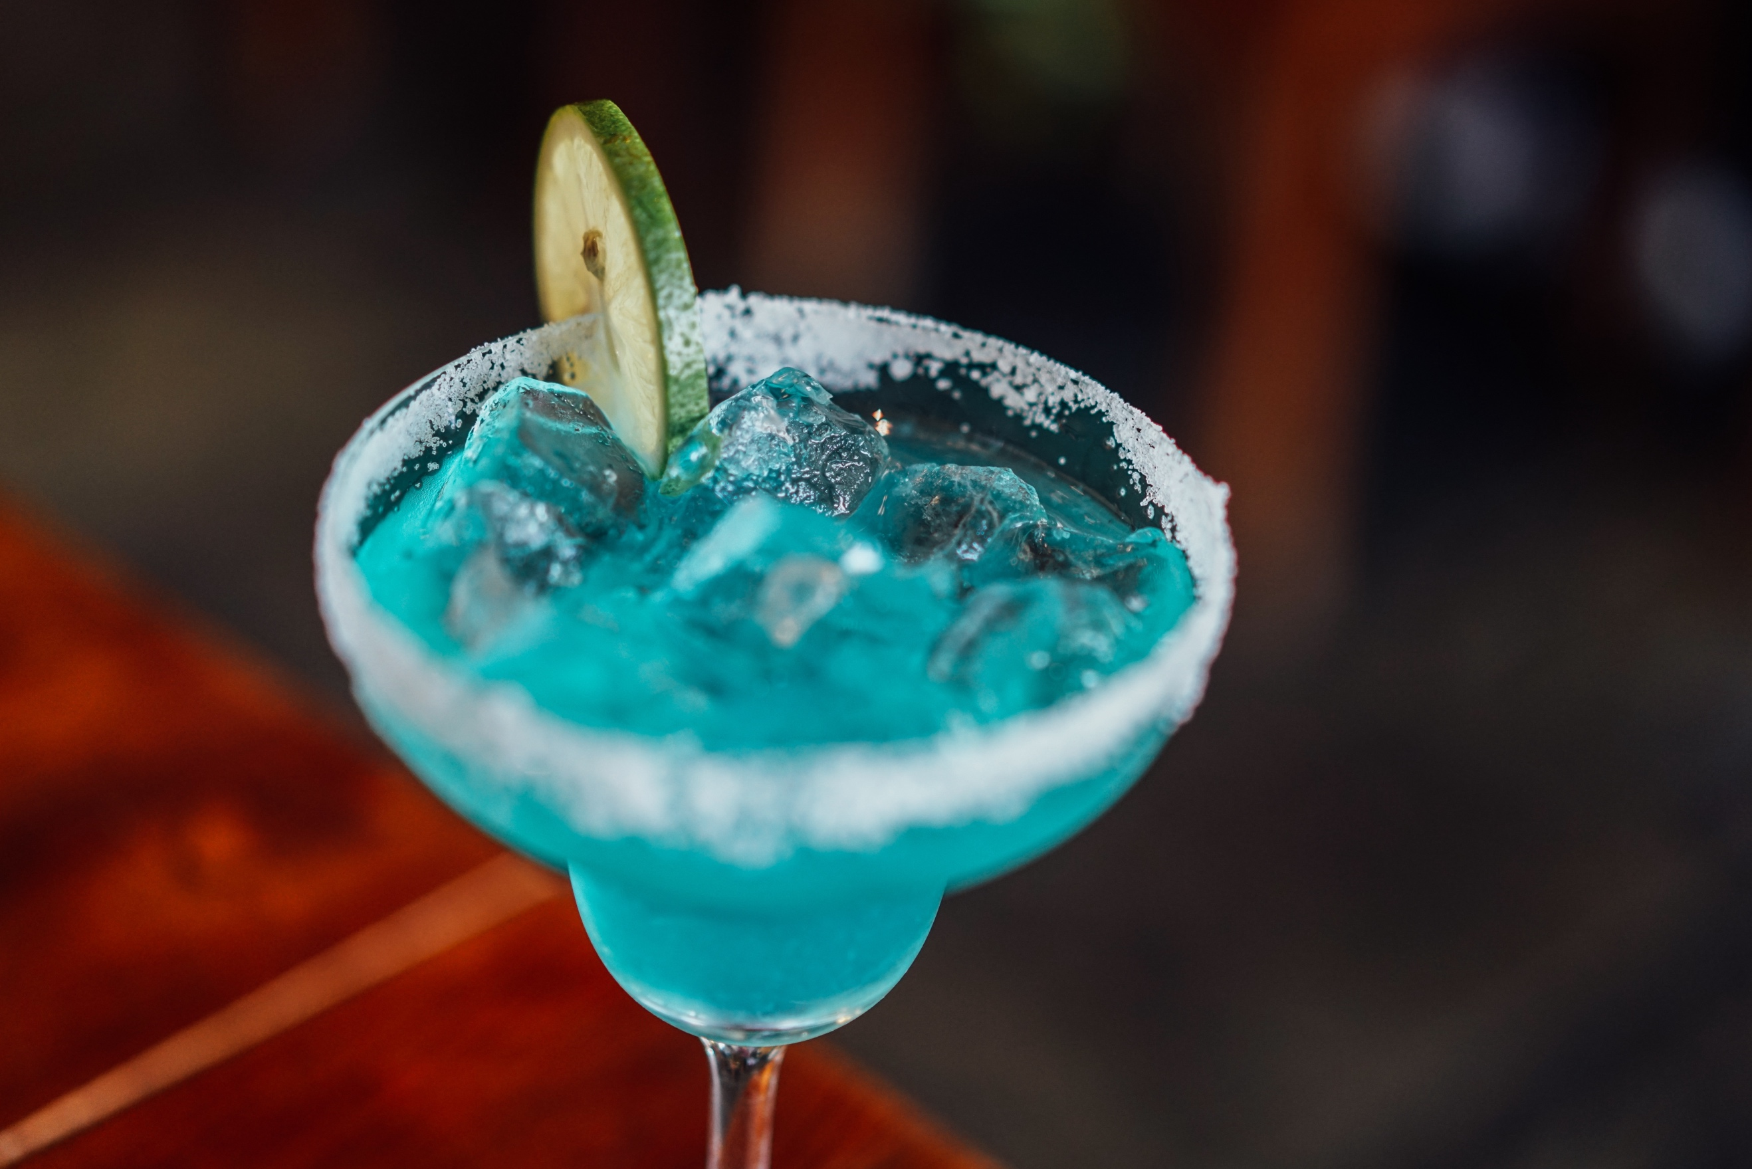 | 6 | 7 | 8 | 9
10  Mother’s Day   | 11 | 12 | 13 | 14 | 15 Opening Day !!  Join us at @ 7 PM for a Fireside Celebration. Popcorn will be served - BYOB | 16
17 | 18 | 19 | 20  Hors d'oeuvres on the Deck 4:00 PM  BYOB | 21 | 22  Breakfast on the Deck 9-10:30 am | 23
24 | 25  Memorial Day Cookout on Deck  5:00 PM   | 26 | 27 | 28 | 29  Breakfast on the Deck 9-10:30 am | 30
31

